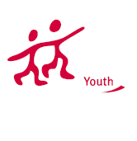
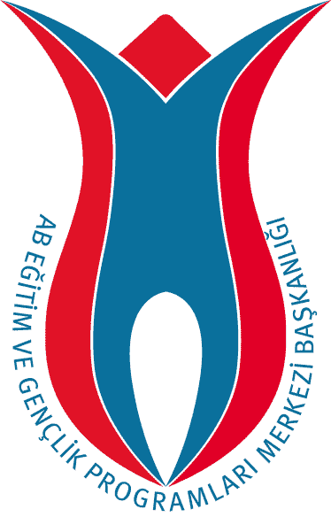
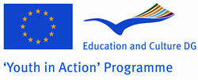
TURKISH NATIONAL AGENCY

PARTNER REQUEST FORM
Please read below before filling in the form:
1- This form should be sent to the email address: partneryouth@ua.gov.tr
2- Only forms written / typed in English is accepted.
3- To mark a check box, please double click on it and select “checked” as the default value, and click OK.
4- Please do not remove any tables or explanations.

About the Organization and Contact Person
Name of the Organisation / Group |  |  | BURSA METROPOLITAN MUNICIPALITY LOCAL AGENDA 21
Address | Ataturk Kongre ve Kultur Merkezi Merinos Parki Ulubatli Hasan Blv. 16190 Osmangazi
City | BURSA | Country |  | TURKEY
Telephone 1 | +902242708210 | Telephone 2 |  | +905324760976
Email 1 | saidtopuzoglu@gmail.com | Email 2
Fax | +902242708212 | Website |  | www.bursayg21.org
Name of the Contact Person |  | Said TOPUZOGLU
Telephone 1 | +905337459946 | Telephone 2 |  | +902242221012
Email 1 | kula_emre@yahoo.com | Email 2

2. About The Project
Project Name: |  | 360° YOUTH

Type of the Project
 | Action 1.1 - Bilateral |  |  | Action 1.1 -Trilateral |  |  | Action 1.1 - Multilateral
 | Action 1.2 - Transnational |  |  | Action 1.3 – Youth Democracy Projects |  |  | Action 3.1 – Youth Exchanges
 | Action 3.1 – Training & Networking |  |  | Action 4.3 |  |  | Action 5.1
If It is Action 4.3 or 3.1 Training & Networking, then the Activity No:  (1- Job Shadowing, 2- Feasibility Visit, 3- Evaluation Meeting, 4- Study Visit,  5- Partnership-Building, 6- Seminar, 7- Training Course, 8- Networking) |  |  |  |  |  |  | 3.2
Activity venue/place |  |  | OSMANGAZI |  | City |  | BURSA
 |  |  |  |  | Country |  | TURKEY
Activity start date |  |  | 25/09/2009 |  | End date |  | 25/09/2010
Aim and Objectives
Project aims & objectives :

- To give space and opportunity to young people to bring their ideas and thoughts into life
- To improve youngsters personal capacity on working together in a multicultural environment
- To empower youth’s active participation on decision making process on local level
- To create new partnership among different organization around the world
- To share good examples and ideas among partners and learn from each others experience.

Planned activities
The main idea of the project is to enable young people to take the responsibility of planning, implementing of a youth initiative which is going to aim the participation of youth to local governments. Throughout the project young people will get together from around the world to build a youth network office which is going to assist all youth to take part in youth related works. All methods including from structural to managerial issues will be created by young people. The office place will be supplied from our organization but the management of this office will be held by young people.

3. About The Group / Participants
Gender Balance | Male |  | Female | Total
Age Range | 13-14 |  | 15-17 | 18-25 |  | 26-30
General Profile of the Group |  | Young people |  |  | Unemployed young people
General Profile of the Group |  | Students |  |  | Youth workers
General Profile of the Group |  | Apprentices /young workers |  |  | Ethnic minorities
General Profile of the Group |  | Disabled |  |  | Disadvantaged youth
General Profile of the Group |  | Youngsters with special needs |  |  | Other

4. Which countries would you like to have partner from?
Our project is open to all program countries
Our project is open to all program and partner countries
I would like to write the list of countries (separated by comas):

5. Any Additional Information

